Subject: Crazy computer scientist shakes the world with his electricity usage algorithm

Hi,
Computers are a very complex field for myself and I try to stay away from
such complicated topics.
But recently I’ve heard a lot of people, including my 16-year-old son about
a new algorithm which was created by a Chinese guy called Satoshi Nakamoto.
I’ve done some research and I stumbled upon a very interesting video presentation
made by a simple guy like us, talking in plain English. His name is James Headrick
and he managed to find a way to plug into a never-ending resources network.
>> Click Here << to watch the free video presentation
Being in the DIY world for more than 10 years now, I’ve seen them all, weird looking devices
which claim to generate hundreds of watts of electricity, DIY solar panels, you name it…
But I can tell that this project is different. It was kept hidden until not very long,
huge corporations made millions of dollars by using this algorithm, and now it’s
time for us to take advantage.
Check out my first freedom box:
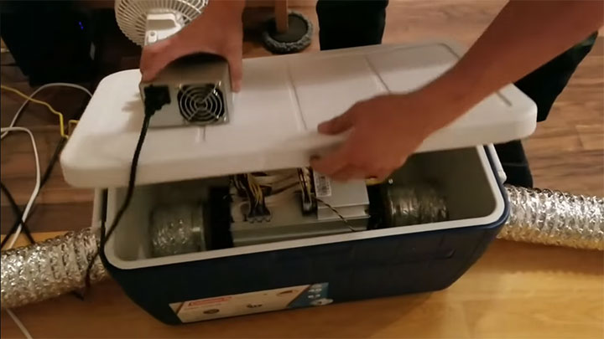
Watch the video presentation to see exactly how I’ve made it.
All the best!

