Link: http://xxxx.mininggear.hop.clickbank.net/?page_id=382

Subject: The freedom box cuts your bill by 90% or more

Hi,
You know me, I am always on the lookout for finding a solution
to cut living costs. While some projects worked out properly,
I’ve also tested a lot which were working just on paper and not in real life.
Lately I’ve been building a project which is supposed to make money
while keeping it connected to the grid. At first impression, it was the kind
of deal that was too good to be true and I’ve approached it carefuly.
After studying the presentation video and page, checked out what others were
saying about this solution online, I’ve decided to build one as well.
I am happy to let you know that this worked out like a charm. Not only that
it works as promised, in the first month I’ve got paid $357 for keeping the device
connected. This was enough to pay my power bill and have some extra cash left.
Here’s a photo of my Freedom Box: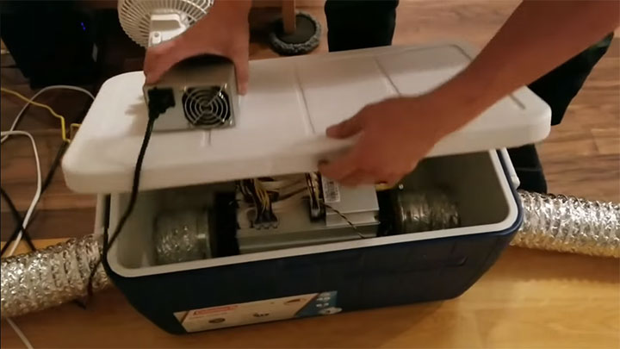
I’ve found this project online 2 weeks ago and I had to see what is all about.
I can say that’s the best thing I’ve seen online on the DIY communities.
There’s a great video presentation that James Headrick put together explaining how
this system works and why it will save you thousands on your power bill and potentially
get you a monthly income if done right.
>> Click Here<< to watch the free video presentation

I’ve heard there is a limited number of people which will get to watch the video
each month, so I would recommend checking it right now while it’s up
Watch The Video now to see how this will save you thousands each year.

All the best!

